## Gamma spectroscopy

### Theoretical background

When gamma photons interact with matter, there are 3 main ways how it is absorbed:

* Photoelectric effect
* Compton interaction
* Pair production

Photoelectric effect – emission of electrons when electromagnetic radiation hits material. For us important because it gives well defined peak in spectrum. Gamma gives all energy to electron and knocks it out. Recoiling electron goes through NaI crystal, loses its energy through ionization, excitation, and production of thermal energy. Some fixed fraction of electron energy will be converted to light photons which hit photocathode and produce photoelectrons. Photoelectrons get attracted to dynode tube (works as accelerator) by positive voltage of anode. Avalanche of electrons arrive at anode and produce electrical pulse which is proportional to energy of incident gamma ray. Electrical pulses can be converted with analog-digital converter and read by software.

Compton interaction – kinematic collision between incident gamma photon and electron in crystal that is free or loosely bound. Maximum energy transfer at 180 degrees. Electron can go in one direction, but photon can go in any direction which reduces energy detected at anode.

Pair production – occurs for minimum photon energy of 1.02 MeV as it equals the sum of rest mass energies of electron and positron. Photon in field of nucleus produces and electron and positron which carry away excess photon energy as kinetic energy. Positron will annihilate in crystal giving two photons of energy 0.511 MeV in opposite directions. They may interact further in crystal through photoelectric or Compton effects.

Scintillator – material that exhibits scintillation when excited by ionizing radiation.

Scintillation – flash of light produced in transparent material by passage of particle (electron, photon, ion).

Scintillation detector – instrument for detecting and measuring ionizing radiation by using excitation effect of incident radiation on a scintillating material and detecting resultant light pulses.

NaI (TI) – Thallium activated sodium iodide crystals used in detectors. When gamma ray enters, then it causes ionization of sodium iodide. Excited states in crystal emit photons, this is called scintillation. Thallium improves efficiency by shifting wavelength of photons into sensitive range of photocathode. Photocathode is negatively charged electrode in a light detection device coated with photosensitive coating. When this is hit by a photon, the absorbed energy causes electron emission due to photoelectric effect.

Example of Co60 gamma spectrum can be seen on Figure 1.

Figure 1 - Gamma spectrum for Co60

### Laboratory instrumentation

Physical equipment for lab is NaI (TI) detector for catching photons, MCA to USB converter and sample material. Simplified diagram of laboratory structure is described on Figure 2.

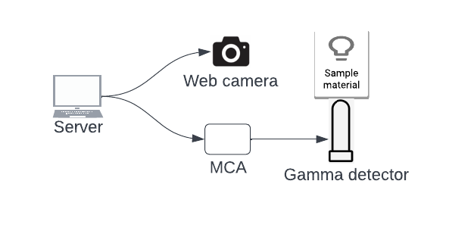

Figure 2 - Hardware components for gamma laboratory

Inner workings and descriptions of NaI (TI) detector are seen on Figure 3.

Figure 3 - NaI (TI) detector

### How to use laboratory

Steps to use laboratory:

* Start gamma spectroscopy laboratory.
* Click ‘Start measurement’, so gamma detector starts collecting sample material gamma counts and plotting results.
* Collecting results may take up to 24h to get meaningful results. Website can be closed, and user can come back later to collect data.
* Save measurement results and leave gamma lab.
* Plot measurement result, find peaks and search table with known chemical elements to determine what sample material was used.